**Network Design**

Computer networks also differ in their design. The two basic forms of network design are called:

client/server and peer-to-peer.

*Client-server* networks feature centralized server computers that store email, Web pages, files and or applications. On a *peer-to-peer* network, conversely, all computers tend to support the same functions. Client-server networks are much more common in business and peer-to-peer networks much more common in homes.

A [network topology](http://compnetworking.about.com/od/networkdesign/a/topologies.htm) represents its layout or structure from the point of view of data flow. In so-called bus networks, for example, all of the computers share and communicate across one common conduit, whereas in a star network, all data flows through one centralized device. Common types of network topologies include bus, star, ring networks and mesh networks.

 Larger companies also maintain their own internal Web sites, called [intranets](http://compnetworking.about.com/cs/intranets/g/bldef_intranet.htm) to help with employee business communication.

A workstation is a computer on which a person performs everyday regular assignments. A workstation is primarily a personal computer (PC). It can also be a laptop.  Almost any modern PC can be used as a workstation and participate to a network.

Topologies:

Network topologies are categorized into the following basic types:

* bus
* ring
* star
* tree
* mesh

More complex networks can be built as hybrids of two or more of the above basic topologies.

BUS Topology

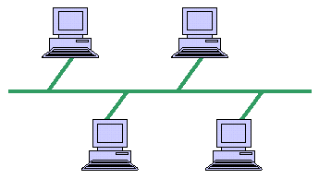

Ring Topology

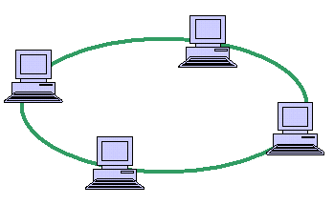

Star Topology

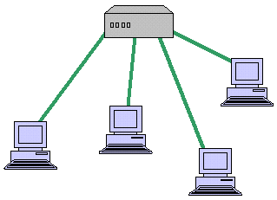

### Network Protocols

Communication languages used by computer devices are called [network protocol](http://compnetworking.about.com/od/networkprotocols/g/protocols.htm). Yet another way to classify computer networks is by the set of protocols they support. Networks often implement multiple protocols with each supporting specific applications. Popular protocols include [TCP/IP](http://compnetworking.about.com/cs/basictcpip/g/bldef_tcpip.htm), the most common protocol found on the Internet and in home networks.

*Source:* http://compnetworking.about.com/od/networkdesign/a/topologies.htm